503IT Communication and Collaboration
Week 2 Session 2 - After-Lunch Activity (14:00-18:00) | Choosing the Right Tool, Planning the Prototype, and Peer Checking GitHub Evidence

Purpose of this 4-hour activity
In the morning session, your group improved the UX and accessibility concept of your cyber-safety game. In this after-lunch session, your group must choose the most suitable development tool, plan the first prototype, organise responsibilities, upload evidence to GitHub, and check another group’s GitHub repository. This activity prepares you for the next stage: building a basic working version or clear prototype of your game.

1. What your group must complete by 18:00
- Compare at least two possible development tools for your game.
- Select one final tool or tool combination and explain why it is suitable.
- Create a clear development plan for your first prototype.
- Assign development responsibilities to all group members.
- Update GitHub with all required Week 2 Session 2 files.
- Check another group’s GitHub repository and give structured peer feedback.
- Update each student’s individual contribution log.
- Prepare and deliver a 2-minute group progress pitch.

2. Tools you may choose from
Choose a tool that matches your game idea, target audience, group skill level, and available time. Do not choose a difficult tool only because it sounds impressive. Your tool must help you produce a realistic prototype.
Tool | Best for | When to choose it | Possible evidence to upload
Canva / PowerPoint | Canvas, storyboard, screen mock-ups, card/board game design | Choose this if your group is making a visual prototype, board game, card game, or early screen design. | PDF canvas, PDF storyboard, screenshots
Scratch | Simple interactive games for children | Choose this if your target audience is young children and your group wants a simple interactive game with characters, buttons, questions, and rewards. | Scratch project link, screenshots, testing notes
Twine | Branching story and decision-based games | Choose this if your game is based on choices, consequences, online safety scenarios, cyberbullying, privacy, or phishing decisions. | Twine file/link, story map, screenshots
Google Forms / Kahoot | Quiz-style games | Choose this if your game is mainly a quiz with feedback, score, and cyber-safety questions. | Game link, question list, screenshots
HTML, CSS, JavaScript / Cursor | Simple web-based game | Choose this if your group wants a browser game and at least one member can work with beginner code or use Cursor responsibly. | index.html, style.css, script.js, README
Construct / Figma | 2D game prototype or interactive screen prototype | Choose this only if your group can learn the tool quickly and use it realistically. | Prototype link, exported screens, screenshots

Important rule
Your group must explain why the chosen tool is realistic. If your target audience is 10-year-old children, the tool should help you create clear instructions, large buttons, friendly visuals, simple interaction, feedback, and rewards.

3. GitHub folder for this after-lunch activity
Create the following folder in your existing group GitHub repository:
Folder name
Week-2-Session-2-Tool-Selection

Inside that folder, your group must create or upload these files:
File name | Purpose | Who should create/update it
tool-comparison.md | Compare at least two tools and decide which one is most suitable. | Tool researcher / any member
final-tool-choice.md | State the final tool and justify the decision. | Project leader or GitHub manager
development-plan.md | Plan the first prototype, tasks, milestones, risks, and responsibilities. | Project management lead
peer-github-review.md | Record feedback received from another group after they check your GitHub. | Minute-taker or evidence lead
meeting-04-minutes.md | Record today’s discussion, decisions, and action plan. | Minute-taker
two-minute-pitch-notes.md | Prepare the final 2-minute group pitch. | Presentation lead

4. How to create the Week 2 Session 2 folder in GitHub
- Open your group GitHub repository.
- Click Add file.
- Click Create new file.
- In the file name box, type: Week-2-Session-2-Tool-Selection/tool-comparison.md
- The forward slash / creates the folder automatically.
- Paste the tool comparison template from this worksheet.
- Scroll down to Commit changes.
- Use the commit message: Add Week 2 tool comparison.
- Click Commit changes.

5. Activity timetable: 14:00-18:00
Time | Activity | Student output
14:00-14:20 | Project restart and GitHub check | Open repository; check morning uploads; create Week-2-Session-2 folder.
14:20-15:05 | Tool exploration research | Research at least two possible tools and complete tool-comparison.md.
15:05-15:35 | Final tool decision | Complete final-tool-choice.md with reasons.
15:35-16:20 | Prototype development plan | Complete development-plan.md with tasks, deadlines, roles, and risks.
16:20-16:55 | Peer GitHub review | Another group checks your repository using peer-github-review.md.
16:55-17:25 | Improve repository after peer feedback | Fix missing files, unclear README, weak commit messages, or incomplete logs.
17:25-17:45 | Prepare 2-minute pitch | Complete two-minute-pitch-notes.md.
17:45-18:00 | Mini pitch and final checklist | Present progress and complete final checklist.

6. Activity A: Tool exploration research
Your group must research at least two tools. You can use the tool websites, YouTube tutorials, screenshots, example projects, and online guides. You are not only checking what the tool is. You are checking whether the tool can help your group build the kind of prototype your game needs.
Create this file in GitHub:
File path
Week-2-Session-2-Tool-Selection/tool-comparison.md

Complete this table in the file:
Tool | What we could build with it | Strengths | Limitations | Suitable for our target audience?
Scratch | An interactive educational phishing-awareness game with animations, scoring systems, player choices, and simple gameplay mechanics | Beginner-friendly, easy drag-and-drop coding, fast prototype development, encourages teamwork and creativity | Limited advanced graphics and professional-level gameplay features | Yes
Figma | Game interface designs, storyboards, menu screens, character layouts, and visual prototypes for the cyber-security game | Excellent for UI/UX design, collaborative teamwork, easy screen planning and presentation visuals | Cannot create a fully playable game independently | Yes / Maybe
Construct 3 | A 2D endless runner cyber-security game with interactive gameplay, scoring systems, and educational challenges | Beginner-friendly, supports 2D game mechanics, easy drag-and-drop system, faster development process | Some advanced features require paid subscription | Yes / Maybe

Questions to answer below the table:
- Which tool is easiest for your group to learn today?
- Which tool best matches your target audience?
- Which tool will allow you to show feedback, rewards, and learning clearly?
- Which tool is realistic for the time you have?
- Which tool will give you evidence to upload to GitHub?

7. Activity B: Final tool choice
Create this file in GitHub:
File path
Week-2-Session-2-Tool-Selection/final-tool-choice.md

Complete the following sections:
Section | What to write
Final selected tool | Write the tool or tool combination your group will use.
Reason for choice | Explain why this tool suits your game, your skills, your target audience, and the available time.
Rejected tool | Name one tool your group considered but decided not to use.
Reason for rejection | Explain why the rejected tool was less suitable.
Prototype output | Explain what you will produce first: quiz, screen mock-up, clickable story, Scratch game, web game, etc.
Evidence to upload | List what you will upload to GitHub after creating the first prototype.

8. Activity C: Development planning workshop
Create this file in GitHub:
File path
Week-2-Session-2-Tool-Selection/development-plan.md

Your development plan must show how your group will move from idea to first prototype. Complete the following tables.
Prototype milestone | What must be completed | Deadline | Evidence
Milestone 1 | Create first simple version of the game/prototype | WEEK3 | 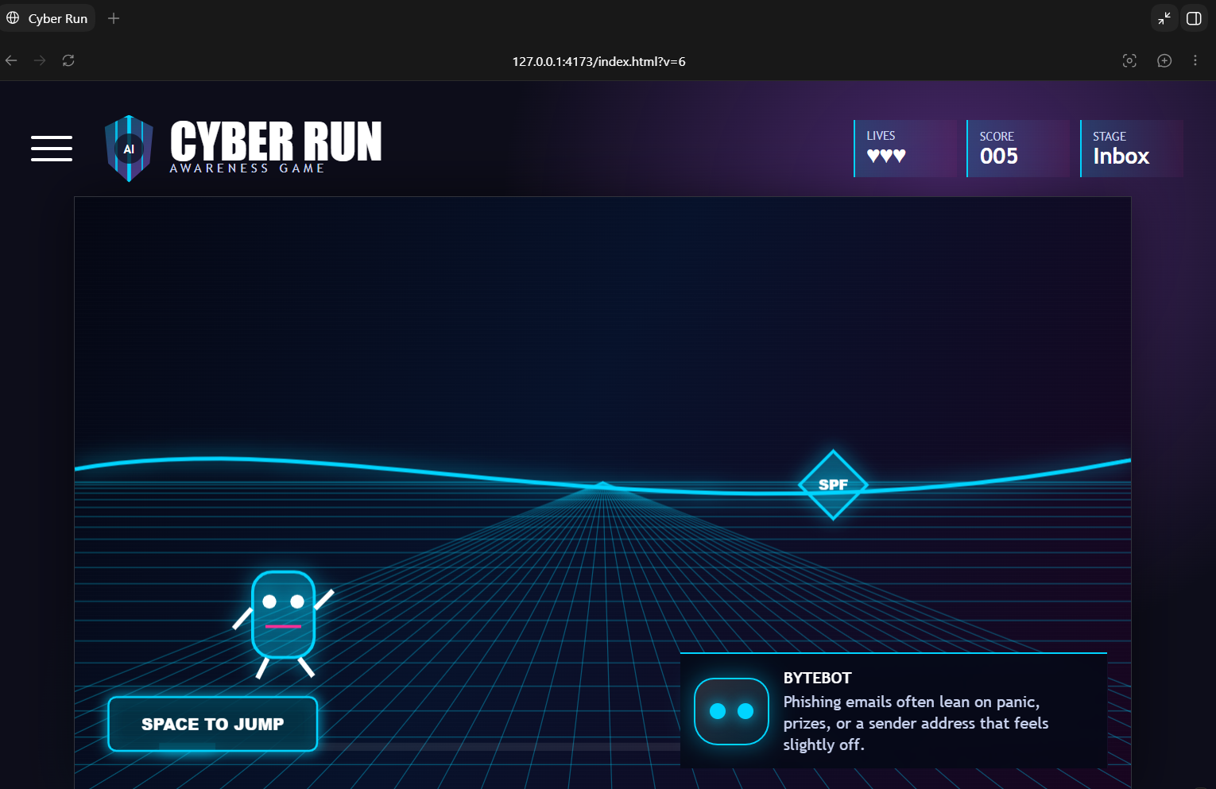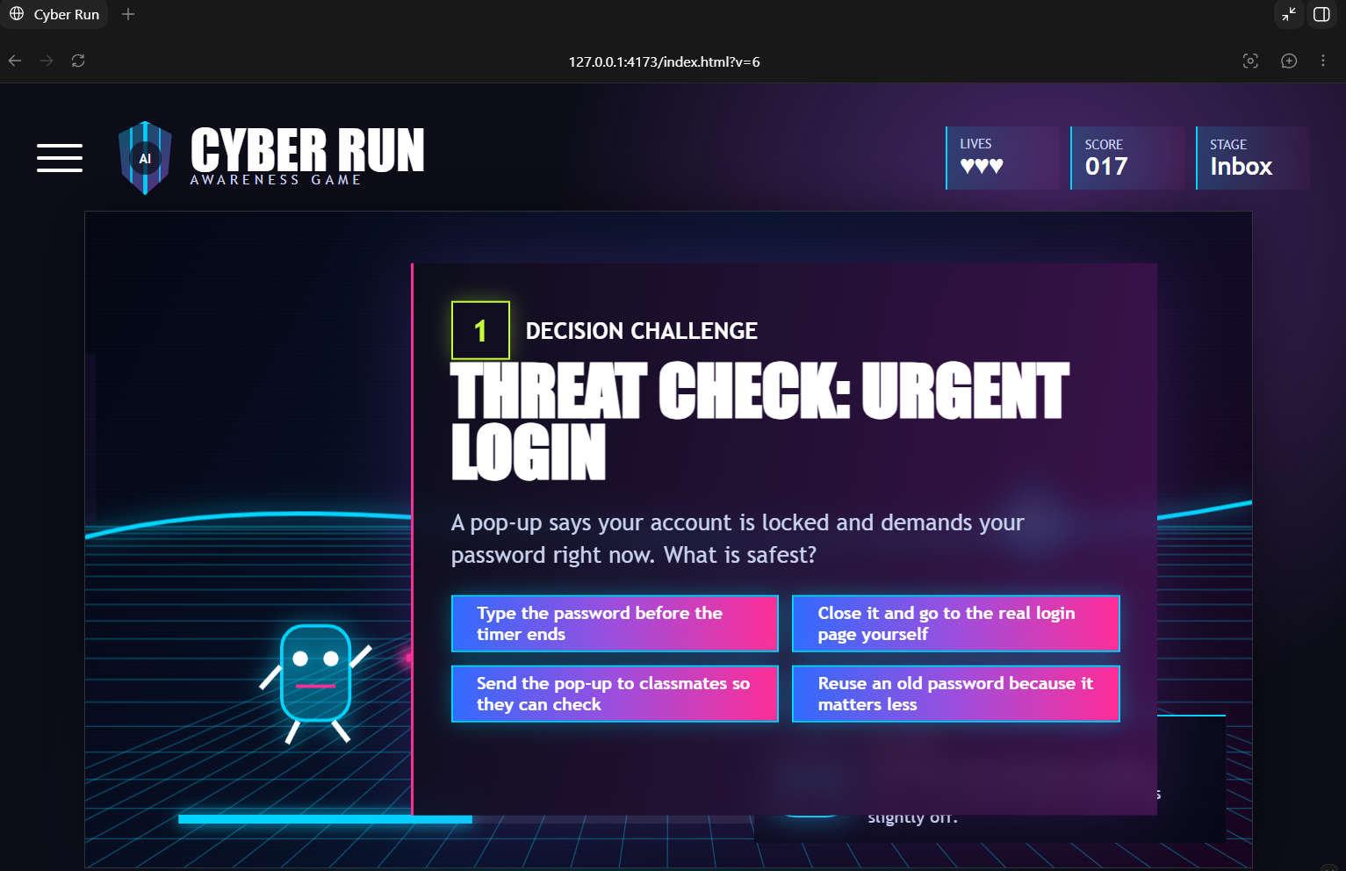
Milestone 2 | Add feedback, rewards, or learning explanation | WEEK3 | 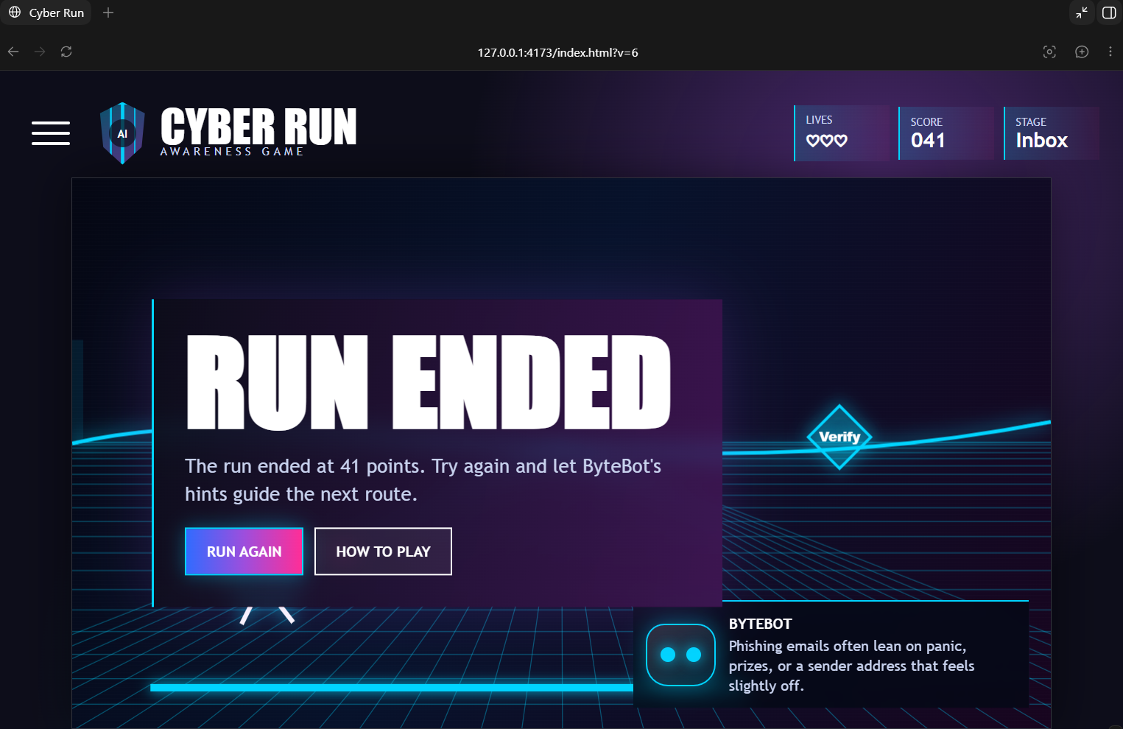
Milestone 3 | Test with group members and collect feedback | WEEK3
Milestone 4 | Prepare presentation evidence | WEEK3 | Slides/prototype demo

Task | Responsible student | Tool | Deadline | Status
Research cyber-safety topic | VIVEK | Google research | Week 3 | In progress
Create game content/questions/story | HADSHEN | Scratch | Week 3 | Not started / In progress / Done
Create visual design/assets | HANGMA | canva | Week 4 | Not started / In progress / Done
Build or prepare prototype | HADSHEN & VIVEK | Scratch/twine | Week 4 | Not started / In progress / Done
Test the prototype | AARBAZ | Scratch | Week 4 | Not started / In progress / Done
Prepare presentation slides | SWASTIKA | Powerpoint & Canva | Week 4 | Not started / In progress / Done

Risk | Possible problem | How the group will manage it
Tool is too difficult | Prototype may not be completed | Use a simpler backup tool such as Canva, PowerPoint, Scratch, Twine, or Google Forms.
Only one person does the work | Weak collaboration evidence | Every member must have assigned tasks and GitHub commits.
AI overuse | Students may not understand the work | Record AI use and edit/check all AI output.
Poor time management | Presentation may be rushed | Set short milestones and check GitHub weekly.

9. Activity D: Peer GitHub review
Each group must check another group’s GitHub repository. This is not to criticise people. It is to help each group improve their evidence before final submission.
Create this file in GitHub:
File path
Week-2-Session-2-Tool-Selection/peer-github-review.md

Use the checklist below when checking another group.
Peer review item | Yes/No | Comment or improvement needed
Repository name is clear and professional | YES
Day-1-Group-Formation folder exists | YES
Day-2-Concept-Development folder exists | YES
Week-2-Session-1-UX-Accessibility folder exists | YES
Game Concept Canvas is uploaded | YES
Storyboard is uploaded | YES
UX/accessibility review is uploaded
Individual contribution logs exist | NO
AI use log exists | NO
Commit messages are clear | YES
More than one student has committed work | YES

After checking, write:
Feedback area | Response
One strength of the repository
One thing the group must improve
One question for the group
Action the group will take after feedback

10. Activity E: Meeting 04 minutes
Create this file in GitHub:
File path
Week-2-Session-2-Tool-Selection/meeting-04-minutes.md

Item | Details
Date | 14.05.2026
Time | 14:00 – 17:00
Group number | E
Chair | VIVEK
Minute-taker | HADSHEN
Attendees | HANGMA , SWASTIKA , AARBAZ
Main discussion points | Comparison of tools, Game planning & designing
Tool decision made | Scratch
Tasks assigned | Researching about phishing, creating visual design & Testing Prototype
Next meeting/action | 15.06.2026

11. Activity F: Update individual contribution logs
Each student must update their own file inside:
Folder
Individual-Contribution-Logs

Add a Week 2 Session 2 update using this structure:
Question | My answer
What did I do after lunch today?
Which file did I create/edit/upload?
What commit message did I use?
What did I learn about choosing a development tool?
What is my next responsibility?

12. Activity G: 2-minute group progress pitch
At the end of the session, each group will give a 2-minute pitch. This is not the final presentation. It is a progress check.
Create this file in GitHub:
File path
Week-2-Session-2-Tool-Selection/two-minute-pitch-notes.md

Use this speaking structure:
Speaker line | What to say
1 | Our game title is...
2 | Our target audience is...
3 | Our cyber-safety topic is...
4 | Today we compared these tools...
5 | We selected this tool because...
6 | Our first prototype will include...
7 | Each member’s next responsibility is...
8 | Our GitHub repository now includes...

13. Final completion checklist
Complete this checklist before leaving the class. Your group must show evidence in GitHub.
Task | Completed? | GitHub file or evidence | Commit message
Week-2-Session-2-Tool-Selection folder created | Y
tool-comparison.md completed | Y
final-tool-choice.md completed | Y
development-plan.md completed | N
meeting-04-minutes.md completed | Y
peer-github-review.md completed | N
two-minute-pitch-notes.md completed | Y
Individual contribution logs updated by all members | Y
AI use log updated if AI was used | N
2-minute pitch delivered | Y

14. Group member completion and signature table
Every group member must complete this table. Do not leave it to one student.
Student name | Student ID | GitHub username | Task completed today | Commit made? | Signature
VIVEK | 15845159 |  |  | Yes / No
HADSHEN | 16247806 |  |  | Yes / No
HANGMA | 15209959 |  |  | Yes / No
AARBAZ | 16200513
SWASTIKA | 15728966 |  |  | Yes / No

15. What your GitHub should show at the end of today
Expected repository evidence
By 18:00, your GitHub should show your project journey: Day 1 group setup, Day 2 concept development, Week 2 Session 1 UX/accessibility improvement, and Week 2 Session 2 tool selection and development planning. Your commits should show that all members contributed, not only one person.

